**SETTING UP APPLICATION ENVIRONMENT CREATE FLASK PROJECT**

# Five Steps have been followed to create Flask Project.

The Steps that we have followed have been described below

**Step 1.** Install Python latest version from python.org

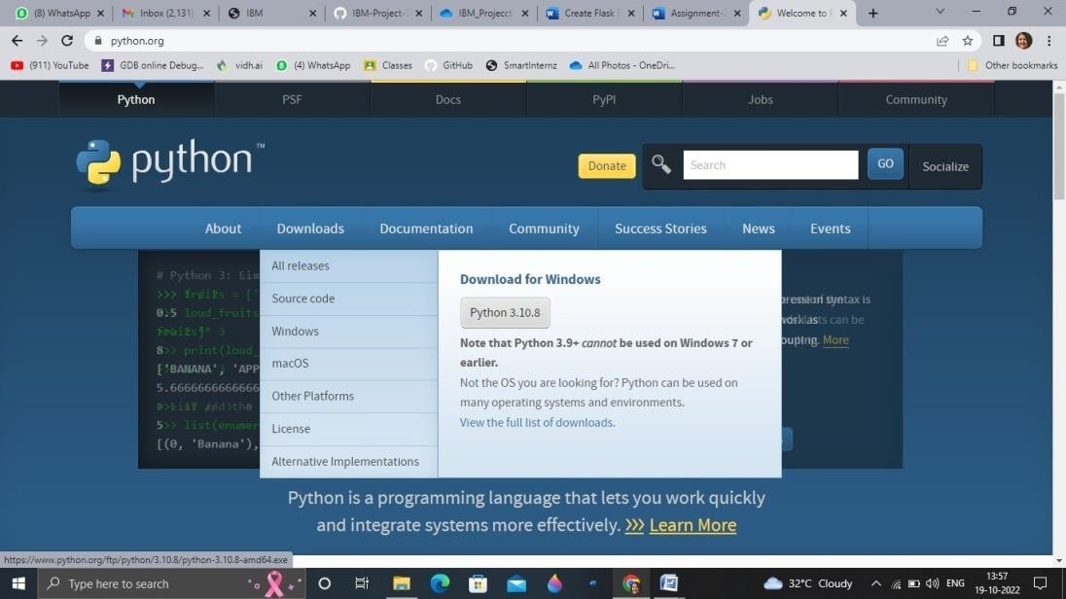

**Step 2**.Install Flask using command pip install flask

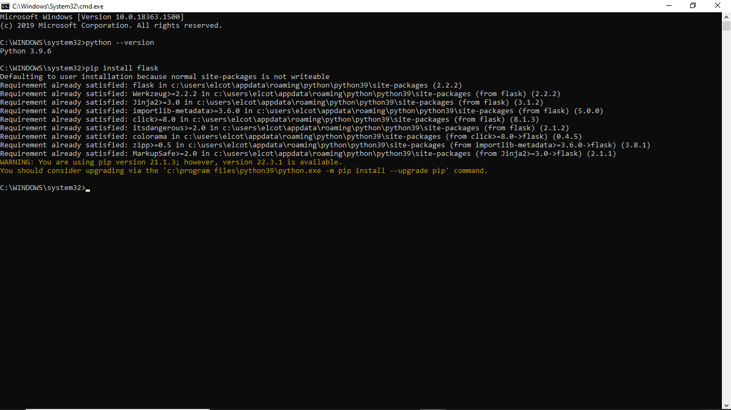

**Step 3**.Open a new Python file and start coding

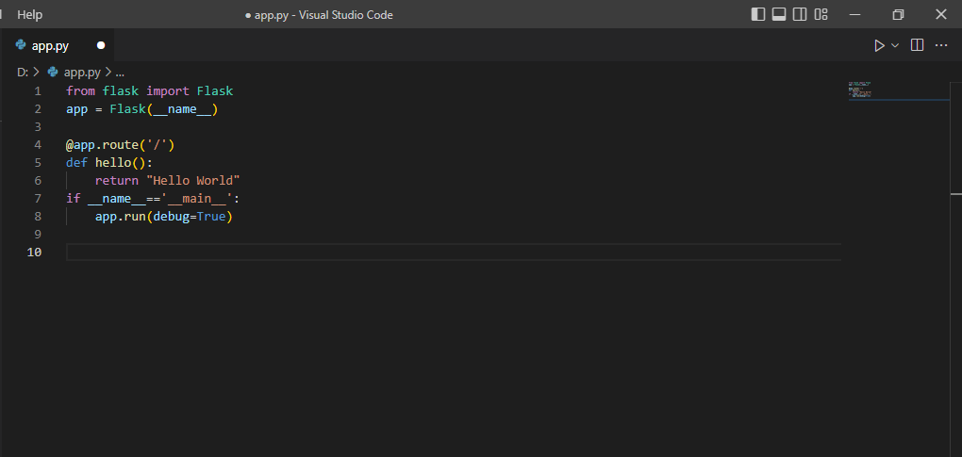

**Step 4**. Run the Python file using command python filename.py

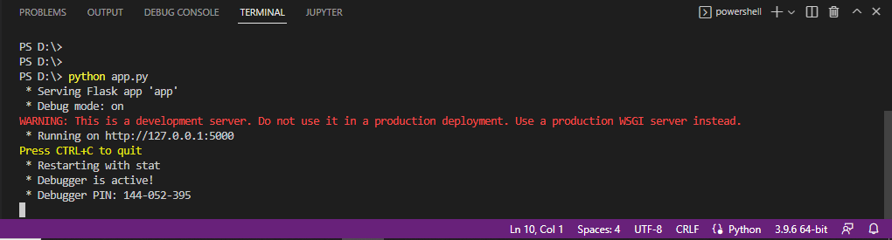

**Step 5**: Open the Ip in browser

